VLSI TASK -2 COMPLETION @ INTERNSPARK

Candidate Information
- Name:Garshakurthi Ajay
- Candidate ID: IS-2026-8378
- Domain: Very Large Scale Integration (VLSI) Intern

Goal :

Synthesize RTL to a gate-level netlist using an academic flow or open-source tool and perform gate-level simulation.

Requirements :
- Use Synopsys DC / Yosys (open-source) for synthesis
- Generate netlist and perform gate-level simulation with timing if available
- Compare RTL vs gate-level behaviour
Design Flow:
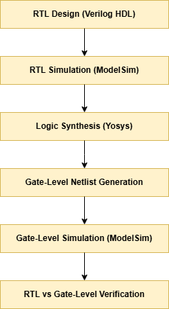
RTL Verification:
The RTL design file (alu.v) was verified using a Verilog testbench (alu_tb.v) in ModelSim.
Simulation Procedure:
- Compile RTL design.
- Compile testbench.
- Run simulation.
- Observe waveform outputs.
- Verify each ALU operation.
RTL simulation confirmed correct functionality for all supported operations.

Deliverables :

1. Synthesis Script & Generated Netlist
Synthesis Tool: Yosys
Synthesis Flow Used:
- Read RTL Verilog design (alu.v)
- Define top module (alu)
- Perform logic synthesis
- Generate gate-level netlist
Generated Netlist:
- alu_netlist.v
Result:
The RTL description of the 8-bit ALU was successfully synthesized into a gate-level netlist using Yosys.
2. Simulation Logs Showing Equivalence
RTL Simulation:
- Design verified using alu_tb.v testbench in ModelSim.
- All ALU operations produced expected outputs.
Gate-Level Simulation:
- Synthesized netlist (alu_netlist.v) simulated using the same testbench.
- Outputs matched RTL simulation results.
Verification Result:
- No functional mismatches observed.
- RTL and gate-level implementations exhibited equivalent behavior for all test cases.
Simulation Files:
- alu_tb.v
- alu.vcd
- ModelSim waveform screenshots
Conclusion:
Functional equivalence between RTL and synthesized gate-level design was successfully verified.
- 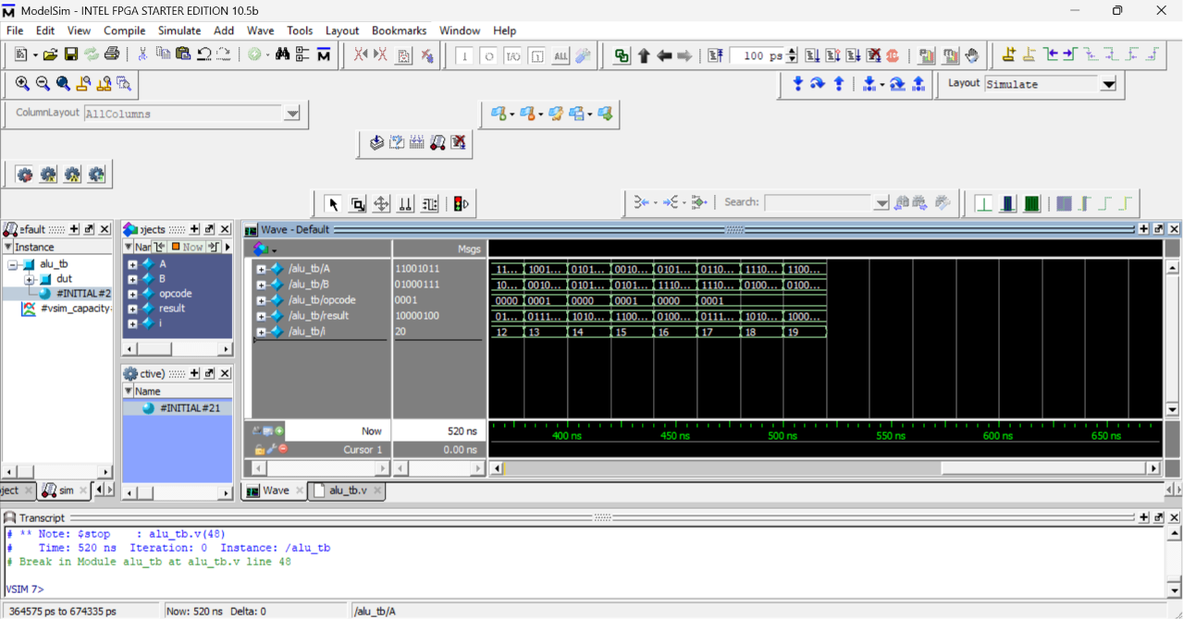

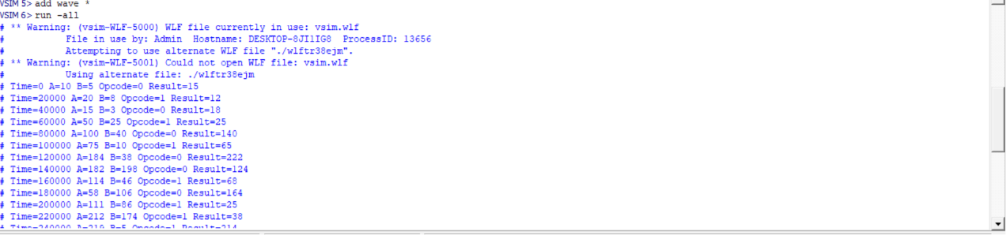

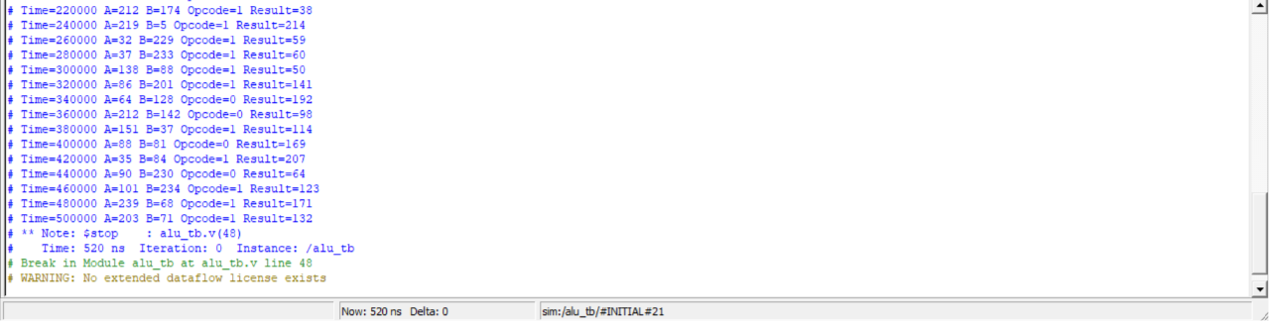

RTL vs Gate-Level Comparison
Parameter | RTL Simulation | Gate-Level Simulation
Addition | Correct | Correct
Subtraction | Correct | Correct
AND | Correct | Correct
OR | Correct | Correct
XOR | Correct | Correct
NOT | Correct | Correct
Increment | Correct | Correct
Decrement | Correct | Correct
Observation:
The gate-level netlist produced identical outputs to the RTL design for all test vectors. Therefore, functional equivalence between RTL and synthesized design was successfully verified.

Final Summary
1. RTL Design: alu.v (8-bit ALU Verilog Design)
2. Gate-Level Netlist: alu_netlist.v (Generated using Yosys Synthesis)
3. Testbench: alu_tb.v (Functional Verification Testbench)
4. Waveform File: alu.vcd (Simulation Waveforms)
5. RTL Simulation: Successfully verified all ALU operations in ModelSim
6. Gate-Level Simulation: Successfully verified synthesized netlist in ModelSim
7. Verification Result: RTL and Gate-Level outputs matched for all test cases
8. Project Status: RTL-to-Gate-Level Synthesis and Verification Flow Completed Successfully.
GitHub Task : https://github.com/AjayGarshakurthi/InternSpark_VLSI_Internship_Tasks/blob/main/VLSI%20INTERNSHIP%20TASK%20-%202.docx

Linkedin Post URL :
https://www.linkedin.com/posts/ajay-garshakurthi-248572362_vlsi-rtldesign-verilog-ugcPost-7475044423580483584-nUKW/?utm_source=share&utm_medium=member_desktop&rcm=ACoAAFoj4dgB5Sv8ySZv8M7rNmoPQc59xNJI5Gw

